Cards and Crosses – Professional practice for game dev

1. Game premise: the idea of this game is to create a more complex noughts and crosses game, layered with some elements of skill and some elements of chance.
2. Materials used to create the game: most of the materials used were virtual, such as the game pieces. The board and pieces for the game was created simply in paint.
3. Rules: (Set-up)

* Each player takes 5 pieces, either noughts or crosses.
* Both players take their own die.
* Separate odd and even cards.

Rules:

* Roll dice. Player with higher roll goes first.
* Players roll their die every turn.
* The number on the die corresponds to which pile of cards they should pick up from. The player must pick up a card every turn.
* If a player rolls and odd number, they must complete the action that is stated on the card. If they roll and even number, the action stated on the card is merely optional.
* Players must continue rolling until one player has 3 pieces in a row.

Aim of the game: get 3 of your pieces in row.

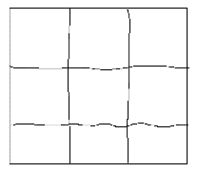 - Board that the game is played on

- Game pieces. Noughts and crosses.

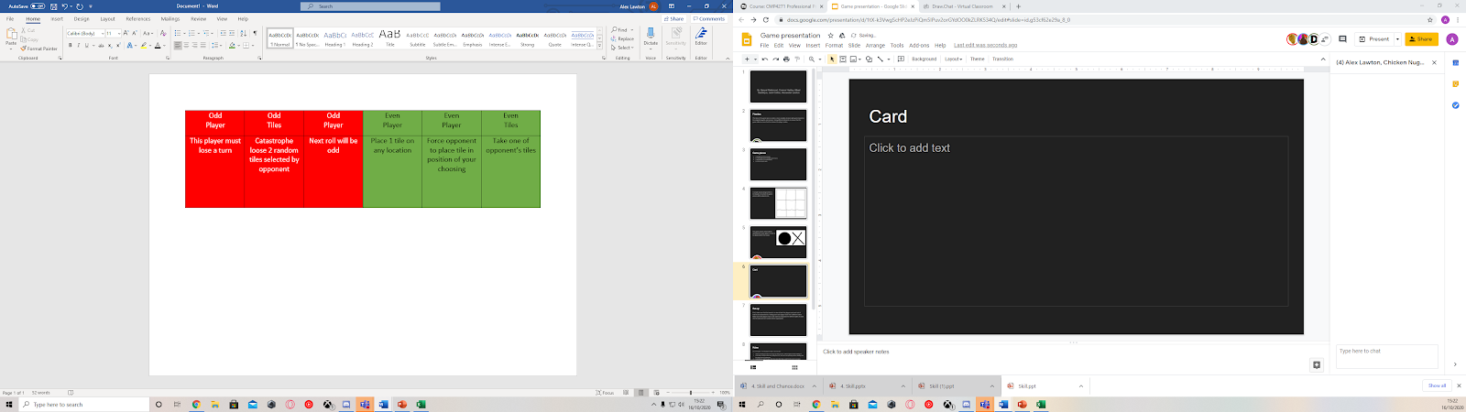 - Playing cards. Odd and even examples.

1. Mechanics: the cards create an element of luck/chance. This ensures that no two games will be played the same and ensures that the outcome of the game is different each time.

Skill is created within the game as they get to choose whether they want to complete certain actions or not. Players are continuously thinking about the placement of their game pieces in relation to their rivals’ pieces on the board.

1. Self-testing: upon initial testing, only the dices were used – there were no cards. What we found is that the games tended to end very quickly and were often repeating themselves. By adding the cards into the game, it lengthened the duration of the game and increased the randomness significantly.
2. Working in a team: our team worked well together delegating certain tasks to each member of the team. This increased efficiency of our work which enabled us to do some play testing. Initially it was difficult to come up with ideas for such a simple game, but many of our team members had bright and creative ideas which they conveyed to the team in a clear and professional manner. Working with my teammates with very easy as they were all polite.
3. What we did we and what we could improve on: Due to technical problems, one of our team members had to present the game alone, which he did confidently and well. What we could have improved on is spending less time on creating simple pieces of artwork and spent more time getting feedback from play testing with other random players, which would help improve our game.
4. Team members: Danyal Mahmood, Connor Hadley, Bilaal Saddique, Jack Collins, Alexander Lawton